Central Database Code breakdown.

# UI Introduction:

Drop Downs and Buttons



 <select onchange="add_columns_to_options(this.value)" name="Database" id="database">



<select name="column" id="column" onchange="columns_equal(this.value)"></select>



<select id="search" onchange="addfilter()"></select>



<button onclick="FilterData()">FilterData<i class="fa fa-solid fa-filter"></i></button>



<button onclick="refresh_data()">Restart<i class="fa fa-refresh"></i></button>



<button onclick="download_data()">Download<i class="fa fa-download"></i></button>

How to navigate in the central database repository

1

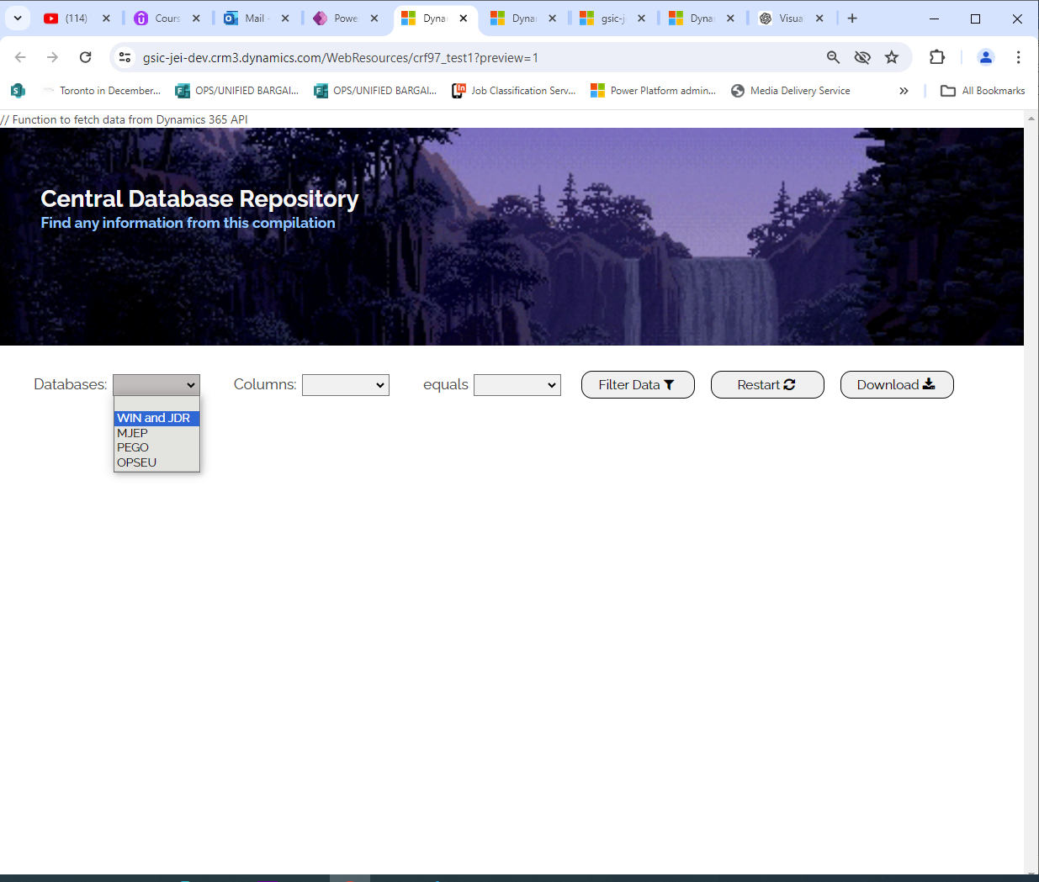

2.

When you select WIN and JDR then it shows this modal.

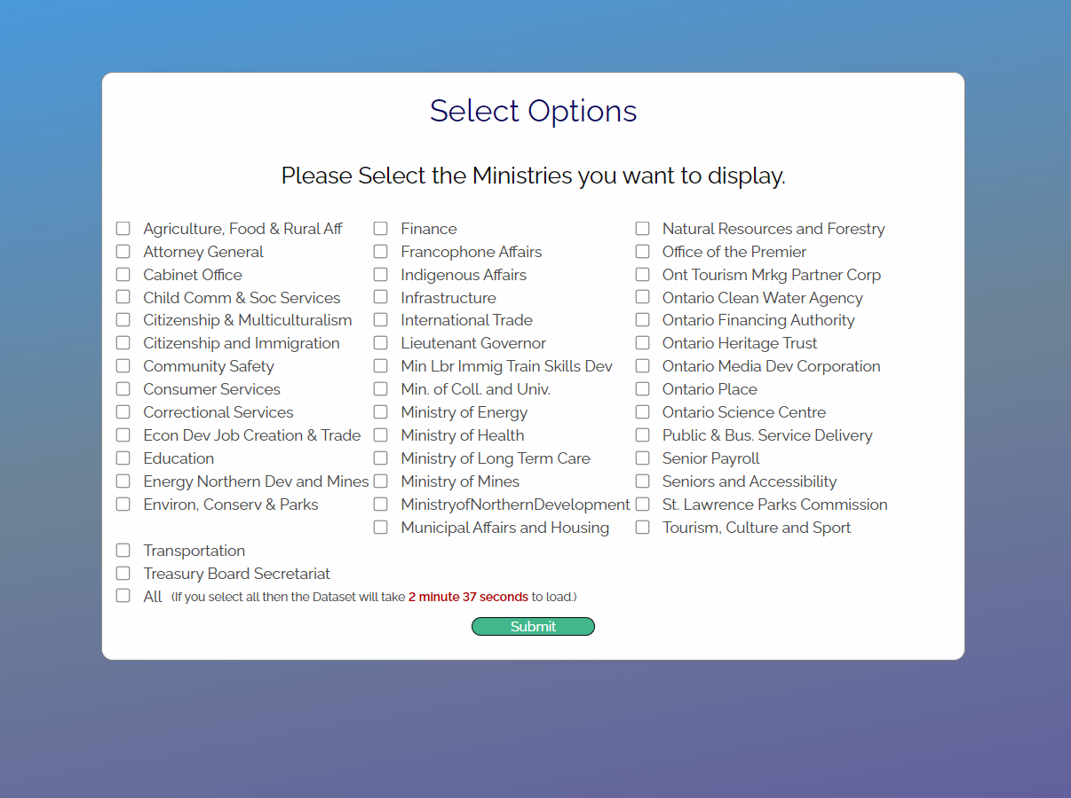

<div id="myModal" class="modal">

      <div class="modal-content">

There is no close button because they need to select a ministry before loading the data.

3.

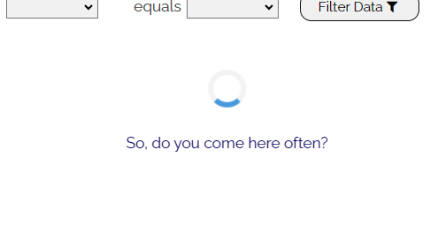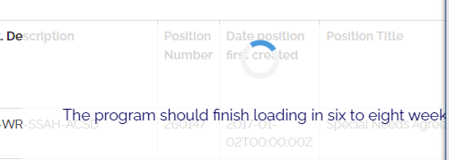

After 4 seconds secondds

<div id="loadingIndicator" class="hidden">

    <div class="spinner"></div>

    <p id="loadingQuote"></p>

  </div>

The quotes updates every four seconds. More quotes can be added here.

4. Functionality of negative icon:

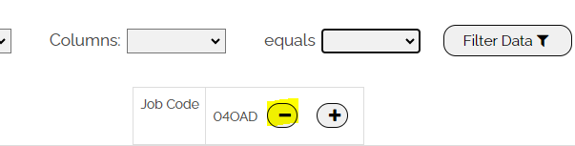

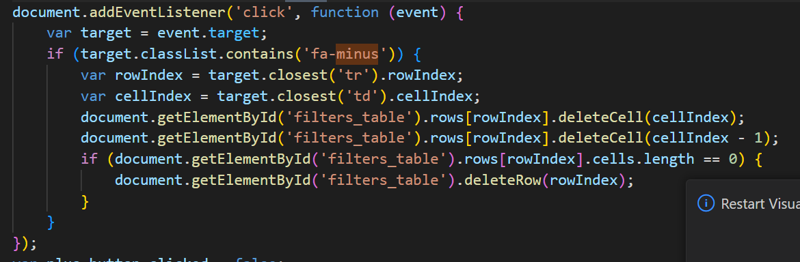

5. Functionality of plus icon:

1. You click on the plus icon then select the filter you want to put on

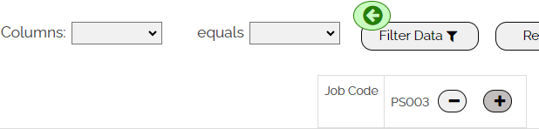

2. Then filter will go beside it when you click on plus sign again then the grey color of the plus icon will go away.

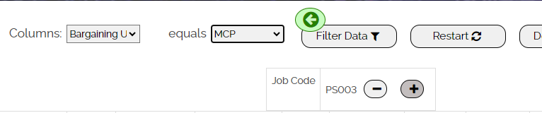

Final_filters table

3. Now you have two filters side by side which means it will filter the data where the job code either has PS003 or unit either has MCP

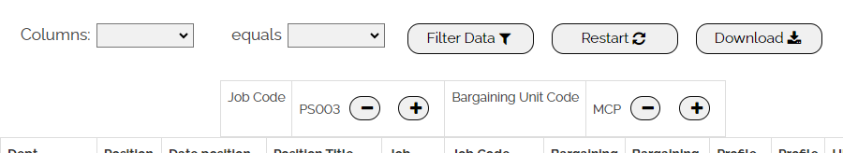

4.After you click filter Data it will filter the data and you can see two rows came in where the bargaining unit is MCP or job code is PS003.

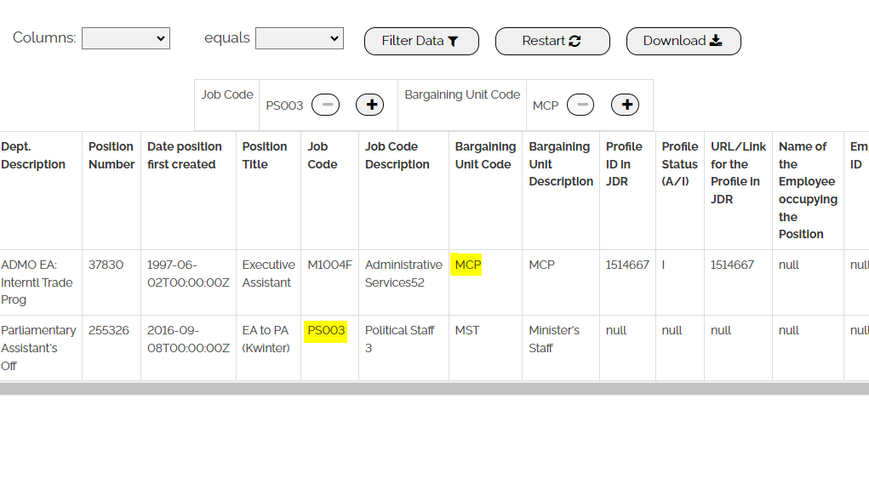

# Code for Adding filters and filtering the data is provided below with comments:

var plus_button_clicked = false;

//here I am adding filters either side by side

document.addEventListener('click', function (event) {

    var target = event.target;

    if (target.classList.contains('fa-plus')) {

        // if (data.length != full_data.length) {

        //   data = full_data;

        //   displayDataOnPage(data);

        // }

        var equal_field = document.getElementById("search");

        //when adding filter for the first time the green button will appear if someone wants to add filter side by side

        if (document.getElementsByClassName("final_filters").length === 0) {

            var button = document.createElement("button");

            button.classList.add("final_filters");

            button.innerHTML = '<i class="fa fa-arrow-circle-left" style="font-size: 30px; display: flex;justify-content: center; color:green"></i>';

            var parentDiv = equal_field.parentNode;

            parentDiv.insertBefore(button, equal_field.nextSibling);

        }

        plus_button_clicked = true;

        target.parentNode.style.backgroundColor = '#c3bebe'

        var key_dropdown = document.getElementById('column');

        var value_dropdown = document.getElementById('search');

        //when the plus button is clicked once and dropdown values are selected then if the plus button is clicked again then the filters will get added side by side

        if (plus_button_clicked == true & key_dropdown.options[key_dropdown.selectedIndex].text != "" & value_dropdown.options[value_dropdown.selectedIndex].text != "") {

            var filter_table = document.getElementById("filters_table")

            var rowIndex = target.closest('tr').rowIndex;

            var row = filter_table.rows[rowIndex];

            // Create new cells

            var newCell1 = row.insertCell(-1); // -1 to append cell at the end

            var newCell2 = row.insertCell(-1);

            var key = key_dropdown.options[key_dropdown.selectedIndex].text;

            var value = value_dropdown.options[value_dropdown.selectedIndex].text;

            let newText = document.createTextNode(key);

            newCell1.appendChild(newText);

            let newText2 = document.createTextNode(value);

            let minus_button = document.createElement("button");

            minus_button.innerHTML = '<i class="fa fa-minus"></i>';

            newCell2.appendChild(newText2);

            newCell2.appendChild(minus_button);

            minus_button.classList.add("sign-button");

            minus_button.classList.add("minus");

            let plus_button = document.createElement("button");

            plus_button.innerHTML = '<i class="fa fa-plus"></i>';

            newCell2.appendChild(plus_button);

            plus_button.classList.add("sign-button");

            plus_button.classList.add("plus");

            plus_button_clicked = false;

            target.parentNode.style.backgroundColor = ''

            const green_button = document.getElementsByClassName("final_filters");

            green_button[0].style.display = "none";

            key_dropdown.value = key_dropdown.options[0].value;

            value_dropdown.value = value_dropdown.options[0].value;

        }

    }

})

//here I am adding filters one below another.

function addfilter() {

    if (plus_button_clicked == false) {

        var key_dropdown = document.getElementById('column');

        var value_dropdown = document.getElementById('search');

        var key = key_dropdown.options[key_dropdown.selectedIndex].text;

        var value = value_dropdown.options[value_dropdown.selectedIndex].text;

        var filter_table = document.getElementById("filters_table")

        let newRow = filter_table.insertRow(-1);

        let newCell = newRow.insertCell(0);

        let newText = document.createTextNode(key);

        newCell.appendChild(newText);

        //var value_table=document.getElementById("words")

        // let newRow2 = value_table.insertRow(-1);

        let newCell2 = newRow.insertCell(1);

        let newText2 = document.createTextNode(value);

        let minus_button = document.createElement("button");

        minus_button.innerHTML = '<i class="fa fa-minus"></i>';

        newCell2.appendChild(newText2);

        newCell2.appendChild(minus_button);

        minus_button.classList.add("sign-button");

        minus_button.classList.add("minus");

        let plus_button = document.createElement("button");

        plus_button.innerHTML = '<i class="fa fa-plus"></i>';

        newCell2.appendChild(plus_button);

        plus_button.classList.add("sign-button");

        plus_button.classList.add("plus");

        key_dropdown.value = key_dropdown.options[0].value;

        value_dropdown.value = value_dropdown.options[0].value;

    }

}

function FilterData() {

    var minus_button = document.getElementsByClassName("minus")

    for (var i = 0; i < minus_button.length; i++) {

        minus_button[i].disabled = true;

    }

    var filter_table = document.getElementById("filters_table")

    var key_values = []

    var value_values = []

    //extracting the last row

    var row = filter_table.rows[filter_table.rows.length - 1];

    for (var j = 0; j < row.cells.length; j = j + 2) {

        var key_cell = row.cells[j];

        key_values.push(key_cell.textContent)

        var value_cell = row.cells[j + 1]

        value_values.push(value_cell.textContent)

    }

    //extracting the filters from the filter table to a list

    const filters = [];

    for (let i = 0; i < key_values.length; i++) {

        var key = key_values[i];

        var value = value_values[i];

        if (value == 'null') {

            value = null

        }

        filters.push({ key, value });

    }

    //console.log(filters)

    if (filter_table.rows.length == 1) {

        data = full_data

    }

    data = data.filter(item => {

        // Check if all filters match the item's properties

        return filters.some(filter => {

            const { key, value } = filter;

            const indexOfElement = columns.indexOf(key);

            return item[data_columns[indexOfElement - 1]] == value;

        });

    })

    displayDataOnPage(data);

}